Project Design Phase-II
Technology Stack (Architecture & Stack)

Date | 19 february 2026
Team ID | LTVIP2026TMIDS46852
Project Name | Importing & Securing Data in ServiceNow
Maximum Marks | 4 Marks

Technical Architecture:
The Deliverable shall include the architectural diagram as below and the information as per the table1 & table 2
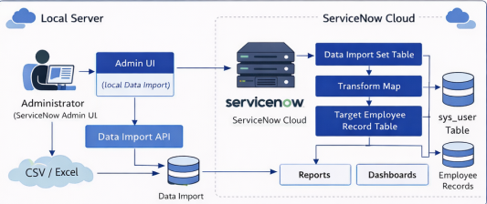

Table-1 : Components & Technologies:
S.No | Component | Description | Technology
 | User Interface | Web-based UI for Admin, HR, Manager and Employee interaction. | ServiceNow Web UI
 | Application Logic-1 | Import Set processing and data validation. | ServiceNow Import Sets
 | Application Logic-2 | Data mapping and transformation logic. | Transform Maps
 | Application Logic-3 | Business Rules for auto-populating department and validations. | Server-side JavaScript (Glide API)
 | Database | Stores employee records and imported data. | ServiceNow Tables (sys_user, Custom Tables)
 | Cloud Database | Managed database service within ServiceNow cloud platform. | ServiceNow Cloud Infrastructure
 | File Storage | Storage of uploaded CSV files. | ServiceNow Attachment Storage
 | External API-1 | Future integration with HR Systems. | REST API
 | Machine Learning Model | Not applicable in current scope (Future enhancement). | N/A
 | Infrastructure (Server / Cloud) | Application deployed on cloud-based ServiceNow platform. | Cloud (SaaS Model)
 | User Interface | Web-based UI for Admin, HR, Manager and Employee interaction. | ServiceNow Web UI

Table-2: Application Characteristics:
S.No | Characteristics | Description | Technology
 | Open-Source Frameworks | Uses built-in ServiceNow platform capabilities. | Technology of Opensource framework
 | Security Implementations | Role-based access control, ACL rules, field-level security. | e.g. SHA-256, Encryptions, IAM Controls, OWASP etc.
 | Scalable Architecture | Cloud-based SaaS architecture supporting high data volume. | ServiceNow Cloud Architecture
 | Availability | High availability ensured by ServiceNow cloud infrastructure. | Cloud Data Centers
 | Performance | Efficient bulk data processing and optimized reporting. | Import Sets, Indexed Tables

